Trisia Baltazar

Due: Oct 11

CIS 310-02-4178

Assignment 6

(A)

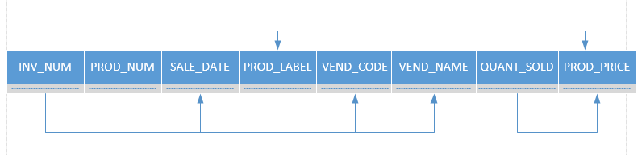

(B) This table is in 1NF if the table has no repeating groups and the primary keys are identified (INV_NUM, PROD_NUM).

(C) This table is not in 2NF because it is in 1NF and there are partial dependences.

A partial dependency occurs when the determinant is part of the primary key. On the table in (A), SALE_DATE, VEND_CODE, and VEND_NAME are partially dependent on INV_NUM. PROD_LABEL, QUANT_SOLD, and PROD_PRICE are partially dependent on PROD_NUM.

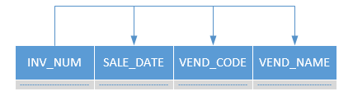

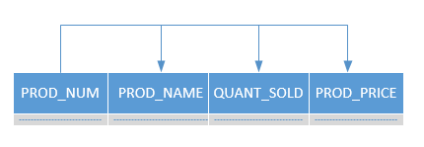

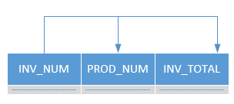

(D) The database above is not in 3NF because it is in 2NF and there are transitive dependencies.

A transitive dependency occurs when a non-key attribute determines other non-key attributes.

QUANT_SOLD and PROD_PRICE shows a transitive dependency where PROD_PRICE is dependent on QUANT_SOLD.

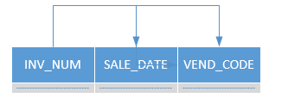

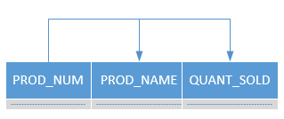

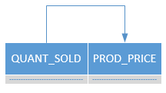

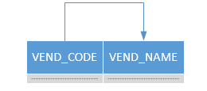

(E)

